Wench Components – Match Component Name to Diagram Location
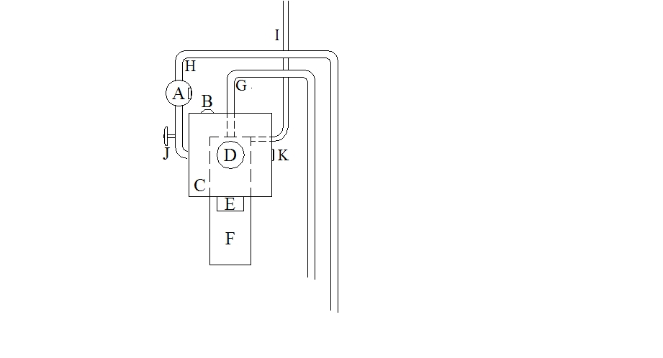
A __________________________ ___ Return Shut-off
Fluid Reservoir
B _____________________________ Fluid Send Line
Fluid Return Line
C _____________________________ Fluid Level & Thermometer
Filter Change Gauge
D _____________________________ Reservoir Cap
Electric Pump Power
E _____________________________ Electric Pump
Pump ON/OFF Switch
F _____________________________ Pressure Release Valve
Fluid Level Dip Stick
G _____________________________ Reservoir Drain Plug

H _____________________________

I _____________________________

J _____________________________
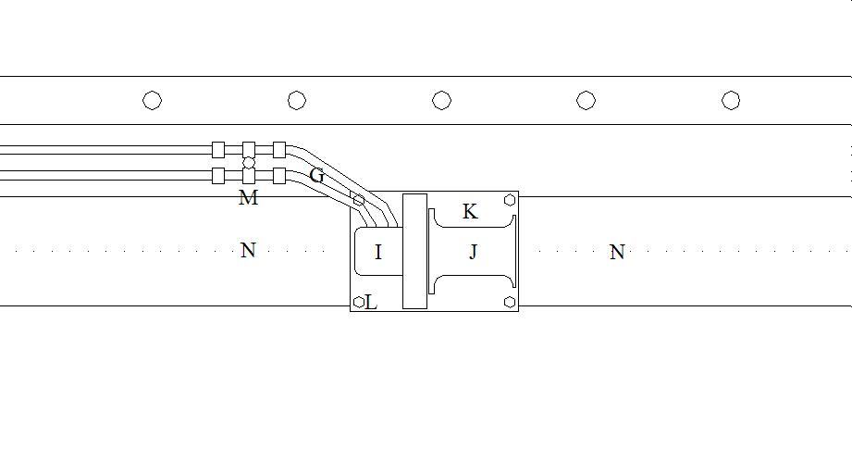

G _________________________________ Platform Bolt
Wench Platform
I _________________________________ Lock-down Beam
Wench Rotor Assembly
J _________________________________ Drum Speed Control
Hydraulic Brake
K _________________________________ Fluid Lines
Wench Drum
L _________________________________ Operator Handle

M _________________________________

N _________________________________

